# Barrel Shifter

Ioan Tugui

IT4T

A Barrel Shifter is a logic component that performs shift or

rotate operations

A Barrel Shifter is a logic component that performs shift or

rotate operations

A Barrel Shifter is a logic component that performs shift or

rotate operations

A Barrel Shifter is a logic component that performs shift or

rotate operations

A Barrel Shifter is a logic component that performs shift or

rotate operations

# Introduction

A Barrel Shifter is a logic component that performs shift or rotate operations. Barrel shifters are applicable for digital signal processors.

Barrel shifters that perform shift right logical, shift left logical, rotate left and rotate right operations depending on the instantiation parameters, if parameterizable, in a single clock cycle. The left and right operation is implemented through inversion of the input and output vectors. The number of multiplexing stages is relative to the width of the input vector.

1. Logical shift

**Logical shift** correspond to (left-shift) multiplication by 2, (right-shift) integer division by 2. In the next figure is presented a logical right shift by 1, meaning division by 2.

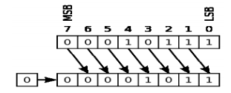

1. Rotate

Rotate is a pretty simple concept which means that as bits are shifted out of the data vector on one side, they are shifted into the data vector on the other side. During this process, all bits from the input are routed to the output. In the next figure is presented a rotate right by 1.

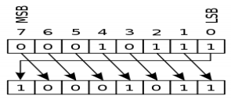

# Implementing Barrel shifter rotating right/left

The block diagram of a barrel shifter right/left by a specific amount is presented in the below figure.

out[7:0]

in[7:0]

RS

p_load

shift_l_r

shift_by[2:0]

Barrel Shifter

CK

Legend:

1. in[7:0] – 8bit data to be shifted
2. shift_by[2:0] – 3bit data representing shift amount, rule: shift_by size must be log2(in)
3. RS – asynchronous reset
4. shift_l_r – 1 bit representing shift direction, 0- left, 1-right
5. p_load – 1 bit representing enabling/disabling parallel loading

In the next figures is represented the output simulation.

1. Rotate left

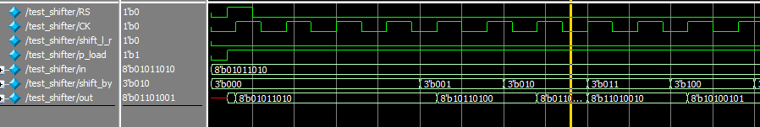

1. Rotate right

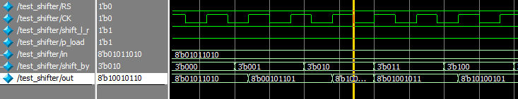

# Implementing Barrel shifter code (Verilog)

Barrel_shifter.v

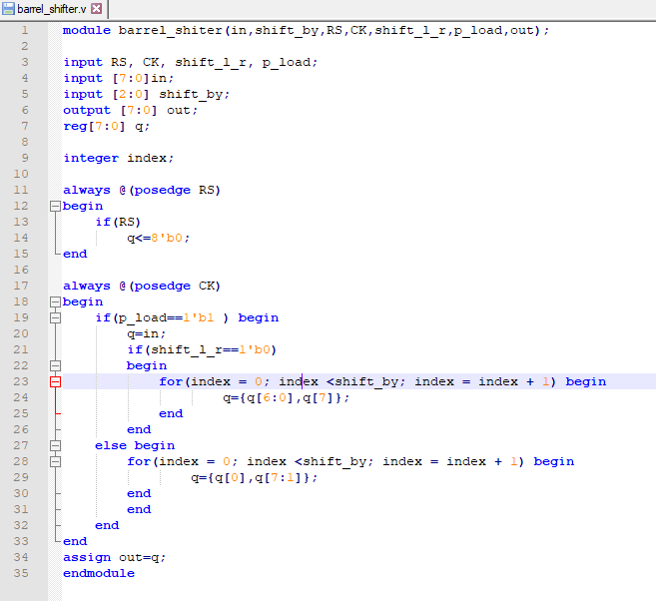

TestBench.v

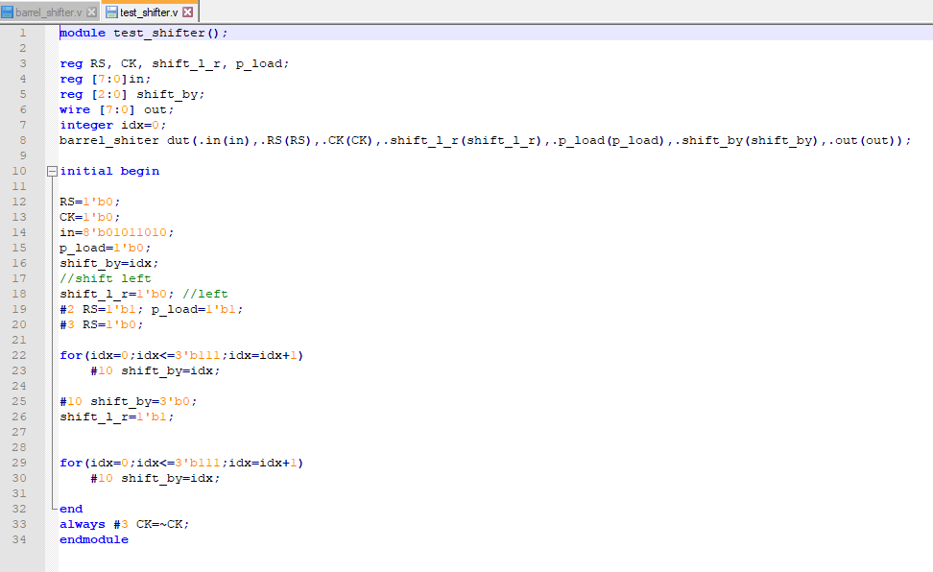

These files can be downloaded at my GitHub account: <https://github.com/itfwf/barrel-shifter>